Chapter 6, Problem 54.

Find the equivalent inductance looking into the terminals of the circuit in Fig. 6.76.
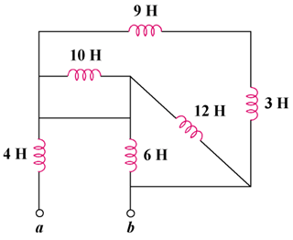

Figure 6.76
For Prob. 6.54.

